|  |
| --- |
| PS2Win |
| Weekly Report |
| Keep Your Time |

|  |
| --- |
| Filipe Brandão  13-05-2013 |

**Team Members:**

Carla Machado

David João

Filipe Brandão

João Girão

João Martins

Mário Oliveira

Rui Ganhoto

**Week 11**, 29th of April to 5th of May

Content

1. Week Activities 1

1.1. Work Executed 1

1.2. Work Analyses 1

1.3. Achievements 1

2. Impediments 1

3. Plans For Next Week 1

4. Progress 2

4.1. Earned value and/or Gantt Image 2

4.2. Effort by task 3

4.3. Individual effort 3

5. Individual log 4

**Images**

Figure 1: Earned Value 2

Figure 2: Week effort by task type 3

Figure 3: Week effort by team member 3

**Tables**

Table 1: List of Contributors ii

Table 2: Version history ii

Table 3: Log of individual effort 3

|  |  |  |  |
| --- | --- | --- | --- |
| **Authors and Contributors** | | | |
| **Date** | **Name** | **Contacts** | **Contribution** |
| 13-05-2013 | Filipe Brandão | a21180276@alunos.isec.pt | Author |
|  |  |  |  |
|  |  |  |  |
|  |  |  |  |
|  |  |  |  |
|  |  |  |  |
|  |  |  |  |

Table 1: List of Contributors

|  |  |  |  |  |  |
| --- | --- | --- | --- | --- | --- |
| **Revision History** | | | | | |
| **Date** | **Description** | **Author** | **Version** | **Approvers** | **State** |
| 13-05-2013 | Creation of first draft | Filipe Brandão | 0.1 |  | Draft |
| 13-05-2013 | Changing state | Filipe Brandão | 0.1 |  | Ready for Revision |
|  |  |  |  |  |  |
|  |  |  |  |  |  |
|  |  |  |  |  |  |
|  |  |  |  |  |  |
|  |  |  |  |  |  |
|  |  |  |  |  |  |
|  |  |  |  |  |  |

Table 2: Version history

# Week Activities

# Work Executed

* SRS was inspected and corrected
* Continuation of the Acceptance Tests plan
* Finished Database Entity-Relationship Diagram
* Review (walkthrough) to Database Entity-Relationship Diagram
* Re-estimation
* Re-planning
* Started the development of the database module

# Work Analyses

A lot of work was completed with success. Sadly, the Acceptance Tests are not totally finished.

The database walkthrough didn’t took too long because the database is simple and it was discussed during the last Progress Meeting.

Re-estimation (Planning Poker) flowed better than the first one with less discussions because, now, the team has the whole software specified and less doubts.

Re-planning was less stressful but the schedule is really tight. Might be reviewed next week depending on the discussion during the next Progress Meeting.

Due to resource availability, the database module development started earlier.

# Achievements

* “SRS Review” Milestone achieved
* Database review.
* Re-estimation.

# Impediments

Some problems regarding the Earned Value Chart (Planned Value) that are still to be solved.

# Plans For Next Week

* Finish database module
* Develop user interfaces
* Start developing the some functionalities such as “Add tasks”, ”Show task details”, “Show task listing”

# Progress

# Earned value and/or Gantt Image

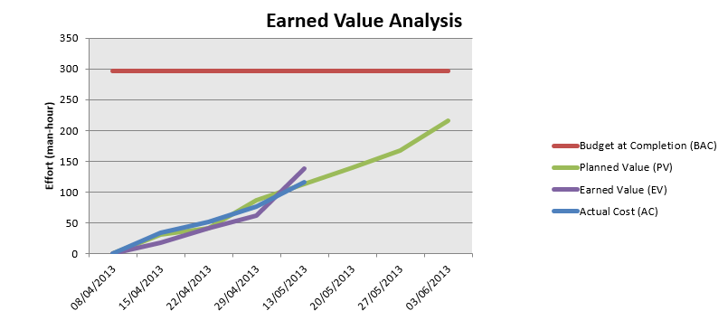

Figure 1: Earned Value

Planned Value = 118h

Earned Value = 138h

Actual Cost = 116h

# Effort by task

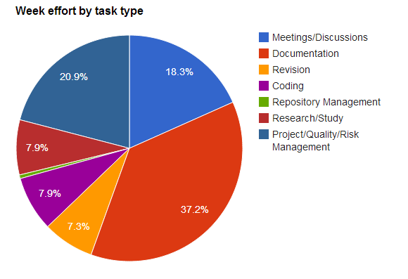

Figure 2: Week effort by task type

# Individual effort

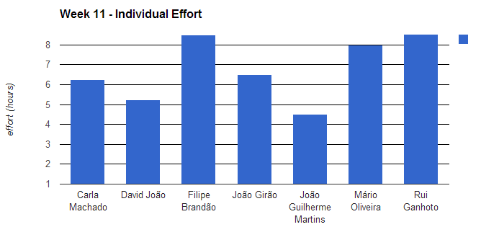

Figure 3: Week effort by team member

|  |  |
| --- | --- |
| **Name** | **Effort(hours)** |
| Carla Machado | 6.25 |
| David João | 5.25 |
| Filipe Brandão | 8.5 |
| João Girão | 6.5 |
| João Guilherme Martins | 4.5 |
| Mário Oliveira | 8 |
| Rui Ganhoto | 9.25 |

Table 3: Log of individual effort

Should be noticed that some members registered tasks from the past week in this week.

# Individual log

**Carla Machado - Tasks done:**

* Study of the SRS to prepare for the Inspection 1.25h
* Approval of weekly report 0.25h
* Review of meeting minute and review of the SRS revision report 0.5h
* Project Plan Reestimation 1.25h
* ER walkthrough 0.25h
* Insertion of the ER model in EA and generation od the criation script 0.5h
* Logs and earned value update considering new task type (10) 0.25h
* Helping the PM with the project planning considering the results of the reestimation 1.5h
* Verification of the document measures of some documents 0.5h

**David João - Tasks done:**

* Tests creation 0.25h
* Project Plan Reestimation 1.25h
* ER walkthrough 0.25h
* Finish of all available tests 1.5h
* Import of test plan into EA and reviews 0.5h
* Continue import of test plan into EA and reviews 1.5h

**Filipe Brandão - Tasks done:**

* Project Plan Reestimation 1.25h
* ER walkthrough 0.25h
* Updated Gant to match progress 1.5h
* Updated Gant with new plan 3.5h
* Updated EV with new tasks and plan 1.5h

**João Girão - Tasks done:**

* Create minute 1.25h
* Project Plan Reestimation 1.25h
* ER walkthrough 0.25h
* SRS rework 2h
* SRS rework 1.75h

**João Martins – Tasks done:**

* Tests 0.25h
* Project Plan Reestimation 1.25h
* ER walkthrough 0.25h
* tests 2h
* test plan into EA and review tests 2.5h

**Mário Oliveira - Tasks done:**

* Upadate repository 0.25hh
* Revision weekly report - Week 9 0.25h
* Project Plan Reestimation 1.25h
* ER walkthrough 0.25h
* SRS rework 2h
* SRS rework 1.75h

**Rui Ganhoto - Tasks done:**

* Team 1 (Javalicious) SRS Inspection Preparation 2.5h
* Weekly Report Approval 0.25h
* Prototyping - DbCreation And Query Execution 1h
* Project Plan Reestimation 1.25h
* ER walkthrough 0.25h
* Database Adapters Connectors and Database Creation in Project 1.5h
* Dabase Connectores Development 1h
* Project Structure Organization 0.25h
* Team 1 SRS Followup 1.25h